Fenny Compton & Shenington Surgeries, The High Street, Fenny Compton, Southam, Warwickshire, CV47 2YG
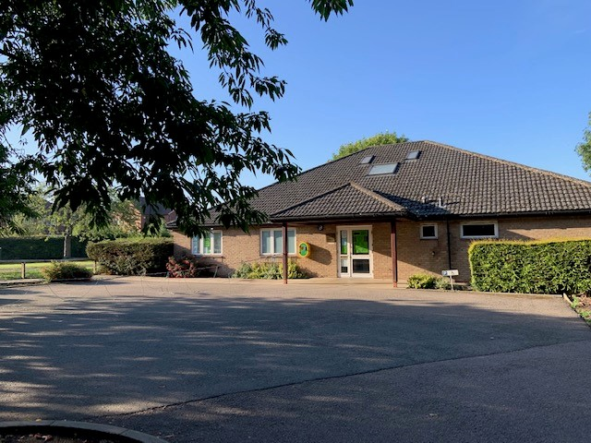
Salaried GP with view to a partnership – 8 sessions - come and join our friendly practice in rural South Warwickshire/North Oxfordshire

We are seeking an enthusiastic salaried GP to join our friendly practice. You will be fully supported by our multi-disciplinary team in order to provide and maintain the highest possible standard of care for our patients. We require 8 sessions per week worked over 4 full days, No weekends or on call commitments after 6.30pm. Future partnership available for the right candidate.

A little more about us:
- 2 purpose built premises to accommodate our growing list size of approx. 5400 patients. Both sites are traditional rural practices and dispense to 98% of our population
- We use EMIS Web, Docman and Lexacom digital dictation & AccuRx
- We are a training practice and welcome medical students and trainee doctors
- We are exceptionally high QOF achieving, rated good by CQC and received excellent results from the recent national patient survey
- Extremely low staff turnover. Current senior partner has 30 years’ service and the newest partner has 8 years’ service
- Our supportive team is made up of 2 salaried GPs, Practice Nurse, HCA and phlebotomists dedicated dispensary team, secretarial and reception support
- We actively participate in our local PCN and Federation
- Very low home visiting rates
- No residential or nursing homes
- We are modernising our systems to lessen the paperwork burden for GPs
- Practice area consists of numerous idyllic villages in countryside close to Leamington Spa, Stratford upon Avon and Banbury - a great place to live and work
- Easy access to motorway network via M40. Less than an hour by train to London from Banbury Station and great local schools, both primary and secondary

We can offer a competitive salary & benefits for the right candidate.

Further information about our practice can be found on our website at www.fennycomptonandsheningtonsurgery.nhs.uk

For further details, please contact Practice Manager, Lisa Yates on 01295 770855 or via email: lisa.yates@gp-m84009.nhs.uk. We would welcome any informal enquiries and encourage practice visits.
Closing date: Friday 24th September 2021

